TITLE: SMART HOME

NAME

MUHAMMAD AKHMAL BIN ZULKEFLY

NO. MATRIC

D021710195

Universiti Teknikal Malaysia Melaka (UTeM)

SMART HOME

NAME

MUHAMMAD AKHMAL BIN ZULKEFLY

NO. MATRIC

D021710195

This report is submitted in partial fulfillment of the requirements for the award of

Diploma of Electronic Engineering

Faculty of Electronic and Computer Engineering

Universiti Teknikal Malaysia Melaka (UTeM)

JUNE 2020

“I hereby declare that this report is the result of my own work except for quotes as

cite in the references.”

Signature: Akhmal

Author: Muhammad Akhmal Bin Zulkefly

Date: June 15, 2020

“I hereby declare that I have read this report and in my opinion this report is

sufficient in terms of the scope and quality for the award of Diploma of Electronics

Engineering.”

Signature: …………………………………

Supervisor’s Name: …………………………………

Date: …………………………………

DEDICATION

To my

Precious Father and Mother

Zulkefly and Saadiah,

My dedicated lecturers, Dr. Mohd Sa’ari

Also, all my supportive friend

ACKNOWLEDGEMENT

First of all, I would like to express my gratitude to Almighty Allah to enabling me to complete this report on “**Smart Home System**”.

Successfully completion of any type of project require helps from a number of persons. I have also taken help from different people for the preparation of this report. Now, there is a little effort to show my deep gratitude to that helpful person.

I convey my sincere gratitude to my Academic Supervisor **Dr. Mohd Sa’ari, Pensyarah Kanan Fakulti Kejuruteraan Elektronik dan Kejuruteraan Komputer, Universiti Teknikal Malaysia Melaka.** Without his kind direction and proper guidance, this study would have been a little success. In every phase of the project his supervision and guidance shaped this report to be completed perfectly.

ABSTRACT

In this busy life schedule, everyone wants to get some comfort and secure life as well. Home Automation used to control home appliances remotely to reduce efforts. Wireless smart home system plays a vital role in human life and increase popularity due to its flexibility, portability and low cost installation charges. Smart Home is very beneficial in everyday life as it reduces human workload, save electricity and reduces worries about home security for working peoples. Main focus in automation is to control light ON/OFF status, fan speed and other home appliances remotely. This system is very beneficial for old age and handicapped people as well for working people, it is a blessing as it alert the person if any nasty situation raised at home in their absence. Though there are various technologies used but in every technology mobile plays important role, to automate home appliances or to get alert in risky situations. Attractive GUI can be used for smart home system, accessible with smart phones, tablet, laptop and PC. A comparative study of smart home system based on technologies like IOT is discussed here.

ABSTRAK

Dalam kesibukkan jadual waktu, semua orang pasti inginkan keselesaan dan kehidupan yang selamat. Rumah pintar berfungsi sebagai alat kawalan untuk mengawal perkakasan di rumah iaitu dapat mengurangkan beban pengguna. Sistem rumah pintar memainkan peranan yang penting dalam kehidupan manusia dan popularitinya meningkat dari aspek ketahanan, kemudahan dan mengurangkan kos pemasangan. Rumah pintar memberi manfaat dalam kehidupan seharian seperti mengurangkan beban, menjimatkan elektrik dan mengurangkan kebimbangan tentang keselamatan dirumah terutamanya ketika orang bekerja. Fokus utama dalam pengawalan adalah untuk mengawal keadaan lampu, kelajuan kipas dan perkakasan di rumah seumpamanya. Sistem ini sangat bagus terhadap orang tua dan kelainan upaya serta orang bekerja, ia seperti rahmat kerana dapat menyedarkan pengguna jika ada situasi yang tidak diingini semasa ketiadaan pengguna. Terdapat banyak jenis teknologi yang digunakan tetapi telefon bimbit memainkan peranan yang penting dalam kalangan teknologi iaitu untuk mengawal perkakasan di rumah atau untuk memberi peringatan tentang situasi berbahaya. GUI yang menarik dapat digunakan dalam sistem rumah pintar, boleh diakses dengan menggunakan telefon pintar, tablet, komputer riba dan PC. Perbandingan maklumat tentang rumah pintar adalah berdasarkan teknologi seperti IOT dibincangkan dalam projek ini.

TABLE OF CONTENT

CHAPTER CONTENT: PAGE

PROJECT TITLE i

STUDENT DECLARATION ii

SUPERVISOR DECLARATION iii

DEDICATION iv

AKNOWLEDGEMENT v

ABSTRACT vi

ABSTRAK vii

TABLE OF CONTENT viii

LIST OF TABLES xi

LIST OF FIGURES xii

LIST OF ABBREVIATION xiv

LIST OF APPENDICES xv

1 INTRODUCTION

1.1 Background

1.2 Problem Statement

1.3 Objectives

1.4 Scope of the Project

1.5 Importance Study

1.6 Chapter Outline

2 BACKGROUNG STUDY

2.1 History of Smart Home System

2.2 Comparison of Existing Project on Smart Home

2.2.1 Wi-Fi module by NodeMCU

2.3 Smart System at Malaysia

2.4 Smart System Comparison

3 METHODOLOGY

3.1 Flowchart

3.2 Arrangement of Circuit and the Component

3.2.1 The Operation of Smart System Circuit

3.2.2 Resistor

3.2.3 Relay

3.2.4 NodeMCU

3.2.5 Code for Blynk Apps

3.3 Simulation Circuit

3.3.1 Schematic Circuit in ISIS

3.3.2 Producing PCB circuit using ARES

3.3.3 Soldering Process

3.3.4 Design

4 RESULTS AND DISCUSSION

4.1 Circuit Operation

4.2 Results of Completed Circuit

4.3 Discussion

5 CONCLUSION AND SUGGESTION

5.1 Conclusion

5.2 Future Recommendations

REFERENCE

LIST OF TABLES

NO TITLE PAGE

LIST OF FIGURES

NO TITLE PAGE

LIST OF ABBREVIATION

LIST OF APPENDICES

NO TITLE PAGE

**CHAPTER 1**

**INTRODUCTION**

* 1. Background

Smart Home refer is a convenient home setup where appliances and devices can be automatically remote from anywhere with an internet connection using mobile or other devices. Devices in Smart Home are interconnected through the internet, allowing the user to control functions such as security, temperature, lights and theater home remotely. This project operates by controlling any appliances at home by using internet and record the data usage in clouds.

The basic Principle of this project is we are using ESP8266 Wi-Fi module and Arduino Uno. From this, we be able to control lights, electric fan and other home appliances through web browser using PC or mobile. Smart home based on the Internet of Things and cloud computing platform can be layered in accordance with the Internet of Things architecture[6][7]. Application layers users use mobile client or personal computer as the client to access Linux cloud server and obtain all kind information in the smart home. The network layer is mainly composed if cloud server platform, which analyze and environment at time and place, also the abnormal scene can be handle in timely manner[1]. Users can use the android mobile phone, android tablet computer through 3G/4G or Wi-Fi signal and Linux cloud server connections to remotely monitoring and management of smart home. At same, the Linux server is establish in the site, which can be convenient for local or remote query and manipulation through the web page.

The main of the paper is to design a smart home automation system for accessing and controlling devices and appliances remotely using Arduino based smart phone application. To be specific, this project aim to design a low cost, extensible, flexible wireless smart home automation system using IOT which employs the integration of wireless communication, cloud networking to provide users to control a variety of devices from remote locations by providing a user friendly interface and ease of installation.

1.2 Problems Statement

Old Style of controlling appliances at home sometimes give user many problem. So this idea is invented because of the problem that user always has when that come to some news devices. The problem can caused by user has become old, ill, and does not have time to close appliances such as lamp, fan, television and any else. The power consumption become higher can also became a problem to user because the user forgot to switch OFF the appliances. Based on problem, the observation of appliances was done to improve the system that overcome the main problem that’s user always had. By applying this system, it can reduce power consumption and electricity wastage. Therefore, it is important to know how to control appliances at home by using Android Phone and how to minimize the electricity used.

1.3 The Objective of the paper:

1. Control Home Appliances via Android Application: to develop an Android application that features selection of manual or automatic mode for controlling home appliances and provide status of the home environment.
2. Sensor Based Control of Appliances: to develop system which controls home appliances based on monitoring the home environment with the help of sensors.
3. Secure connection channels between Application and Arduino: to utilize secure protocol over Wi-Fi and RF with the goal that different devices cannot control the appliances.
4. Control Home Appliances by any Wi-Fi capable devices (Arduino): to make the home appliances flexible in control, any Wi-Fi capable devices can have remote access to the appliances.
5. Extensible platform for future enhancement: to make the application highly extensible, with plausibility of including more features in the future enhancements.

1.4 Scope of the Project:

This project focuses on the development of controlling any appliances at home along with electricity energy saving when a user not at home. This project is to control appliances using ESP 8266 and Arduino as third party. The concept of this system is to control the appliances using a Wi-Fi and at the same time can reduce waste electricity usage in our daily life. When the user forgot to switch OFF any appliances at home they can easily switch OFF.

1.5 Important of Study

One of the important of study is to learn in designing a circuit and making PCB board using Proteus 8 Professional. The circuit is created using ISIS before transfer to ARES for actual circuit developed. After that, the circuit is design on breadboard to test it out. Besides, each component used in circuit can increase understanding of its functions and working principals. For examples, the polarities of ESP8266, variable of coding and type of component are learn during project. Last but not least, the main importance of this project is to overcome problem when connecting to Wi-Fi using ESP8266.

1.6 Chapter Outline

The Smart Home system by using ESP 8266 and Arduino was describe the about the problem that always occur and the innovative design or improvement of system controlling appliances at home. All detail about this project was defined in every chapter of this report as shown below.

**Chapter 1:**  In this section will give a brief introduction of the project. Some explanation about development of smart home system will be considered to acknowledge the system. The problem statement, objectives, scope, the importance of study and the project outline for the whole project are clearly explained in this chapter.

**Chapter 2:**  This chapter will discuss about source or article that related to the project. There are many source or researches done before and from there details about this project are known and can understand briefly about the project.

**Chapter 3:** This chapter will discuss on steps involve completing project. There are several steps to be applied in designing smart home circuit. This part provided of project flowchart, methodology that being used and the explanation about hardware for this project.

**Chapter 4:**  In this section will shows the result obtained that have been achieved throughout the semester. In this section also will discuss about the result of the result of project based on the video simulation testing and finished project.

**Chapter 5:** This chapter will describe about conclusion and recommendation for the appliance control by smart home system. This section includes project summary, project finding and further recommendation to improve the project.

**CHAPTER 2**

**BACKGROUND STUDY**

This chapter will discuss about sources or article that related to the project. There are many sources or researches done before and from there details about this project are known and can understand briefly about the project. In this chapter the theoretical background, literatures review of previous work, and summaries about the previous work will be covered.

2.1 History of Smart Home

The history of Smart Home are begin from IOT (Internet of Thing) that invented from 1800s. Smart Home has been list under IOT (Internet of Thing) because it can do wireless thing that meets term of IOT. So, IOT is define as machine communicating with another since early 1800s. Machines have been providing direct communicating since the telegraph was developed in 1830s and 1840s. It described as “wireless telegraphy”, and the first radio transmission took place on June 3, 1900. This devices providing another necessary component for developing the Internet of Things. The development of computer began in the 1950s.

The internet, itself a significant component of the IOT. It started as part of DARPA (Defense Advanced Research Projects Agency) in 1962 and evolved into ARPANET in 1969. This IOT was quickly followed by privately owned, commercial satellites being placed in orbit. Satellites and Landlines provided basic communications for much of the IOT. When thinking of the IOT, consider the idea, any device capable can be interconnected with other devices.” The IOT is ripe for new and creative ideas to add to tasks already in use. The IOT can be used to organize such things as transportation networks. “Smart cities” can use it to reduce waste and maximize the efficient use of energy. Such likes Smart Home that developed in this project its used IOT system that’s explained how its work wireless.

The smart home is not recent creation. It has been prevalent in the form of a concept among the consumers and industry experts. The smart home concept started with the invention of remote controls, unveiled by Nikola Tesla in 1898.

The early 1900s witnessed the industrial revolution, which paved the way for the introduction of first home appliances. In 1901, the first vacuum cleaner was introduced, followed by cloth dryers, washing machines, refrigerators and electric dishwashers. These are not ”smart” appliances, their introduction was game changer for people of the 20th century. During the 1930s, the inventors turned their attention to home automation technologies, but the idea didn’t materialize until1966, Echo IV, the first smart automation system was developed. This device allowed consumers to created computing shopping list, control the temperature of the home and turn appliances “on” and “off”. Created in 1969, the kitchen computer could create recipes but the device never became a commercial success due to its price. The development of the microcontroller in 1971 resulted in price reductions for electronic devices, making the technologies more accessible. The development of the microcontroller in 1971 resulted in price reductions for electronics devices, making the technologies more accessible. In 1991, a concept called “Gerontechnology” was introduced, which combined gerontology with technology aimed at making the lives of senior citizens easier. Several new technologies were introduced in this sector during the 1990s.

The early 2000s were marked by the rapid increase in the popularity of smart home technology. Different technologies emerged and were slowly integrated in the homes. Smart homes started to become affordable options and therefore viable technologies for many consumers. Home networking, domestic technologies and various other consumer gadgets became available. Smart home automation is ubiquitous in the current market. Consumers are now able to control the heating, TVs, lights, doors and alarms via remote controllers and smartphones.

2.2 Comparison of Existing Project on Smart Home System

2.2.1 Wi-Fi Module by NodeMCU 8266

Wi-Fi module is a type of electronic system that the other devices can connecting to this type connection. Many type connection has been introduces such as Bluetooth Module, Global System for Mobile Communication (GSM) and etc. In wireless network, there are 3 basically type network such as WAN, LAN and PAN. As Explained, NodeMCU includes firmware which run on ESP8266 Wi-Fi SOC from Espressif Systems and hardware based on the ESP-12 module. NodeMCU provides access the GP10 (General Purpose Input/Output). A wireless system can used for many application that can give the information to the user as much they want it. All of these application has been used this day. These system has become the important part in life because it can used in many kind thing. Wi-Fi module is an example development for Smart system in these days. With it, the user can get control in many kind thing such as control appliances at home, technology at industry and the other technology. This ability means that wireless system can play a key part in our part of life. This can bring more benefit to human life and make a big change in every sector.

2.3 Smart Home system in Malaysia

One of the examples that exist in the market for smart home control are a system home automation for the physically disable people. Its architecture includes an array of IR (infrared radiation) sensor modules, an ultrasonic sensor (HC-SR04) module, Bluetooth module, a Microprocessor Unit (MU) and an array of relays that are connected to appliances. The sensor feed the state data of appliances to MU which uses the relay to trigger the appliances. Door will automatically open and close when people approaches the door. But the disadvantage of this system is that it is not specifically designed for disability people [7]. The Figure below show to us about smart system that exist at Malaysia.

Figure:

2.4 Smart System Technology Comparison

Nowadays, there are several type of smart home technology such as controlling using Wi-Fi or Bluetooth module or GSM or PIC Microcontroller with ZigBee. These type of technology can be classified according the Feature and its disadvantage.

|  |  |  |
| --- | --- | --- |
| **Technology** | **Feature** | **Disadvantage** |
| GSM | Access home appliances and control home security by sending and receiving commands in form of SMS, MQ2 and MQ7 sensor used to sense gas leakage. | Delays in sending commands in case of weak mobile network |
| Bluetooth | For Bluetooth technology android based GUI is developed to help owner to communicate with his smart home. | Bluetooth have a range limitation of 100 meter so cannot access system outside range. |
| IOT | Sensors and IOT enable devices used to satisfy the smart home condition. | In case of sensor failure whole system will collapse because lots of dependency on sensor. |
| PIC Microcontroller with ZigBee | Voice based command accepted. Relays are used to control home appliances and microcontroller is central processing unit. | Low end controller. No inbuilt communication module. |

Table above shown Comparison of Smart Home System

**CHAPTER 3**

**METHODOLOGY**

In this chapter will discuss about every process or step which has been done to complete the project. Besides, the tools and components used in this project is explained in more details such as function, advantage and disadvantage of components used to perform the project successfully. Furthermore, the process in designing the prototype is also shown.

3.1 Flowchart of Work

Create the circuit in Proteus (ISIS)

NO

Stimulate the circuit

YES

Develop the circuit on breadboard

Transfer netlist from ISIS into Ares

NO

Test the Circuit with 5V

Function

YES

Based on the flowchart above, there are steps required to complete the project. First step is do research and study to find any information related to the topic chosen. The information gained from Thesis, books and website. After that, the simulation are created using several software such as Multisim and Proteus 8 Professional to look the results of the simulation. When the simulation is done, the components used is obtained from component store in faculty and Online. Due to MCO movement, the circuit must do at home and simulate on Breadboard. It also to make sure the component can operated well. If there is problem with the design circuit, the research is must to solve it. After that, netlist from ISIS is transferred into ARES to arrange the component on circuit. Since PCB circuit cannot be done, the circuit must be done on breadboards and take a video to show its function.

3.2 Arrangement of circuit and Component

To produce a complete circuit for our project, such as find suitable tools, suitable software and equipment are required. Besides, all functions and steps for installation for components need to learn to complete the project.

3.2.1 The Operation of Wi-Fi system for Smart Home

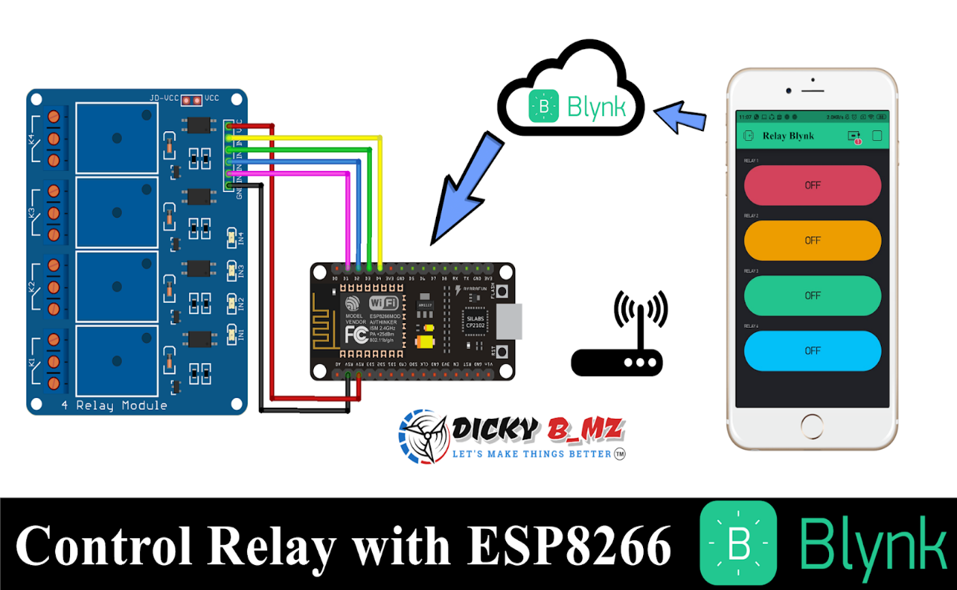  
 Figure 3.1: Operating System Figure

The circuit in Figure 3.1 is used for the project. The Relay circuit is operated when Nodemcu 8266 is connected. Nodemcu 8266 is an open-source firmware and development kit that helps to prototype or build IOT products. It include firmware that’s run on the ESP8266 Wi-Fi SOC from Espressif System.

3.2.2 Resistor

Resistor is electrical or electronic components which resists the flow of current across the resistor. Resistor devices may be provided a fixed, variable, or adjustable value of resistance. Resistor values are expressed in Ohms, the electric resistance unit. A general class description for cylindrical resistor made by deposition a carbon film on the surface of a center core insulators.

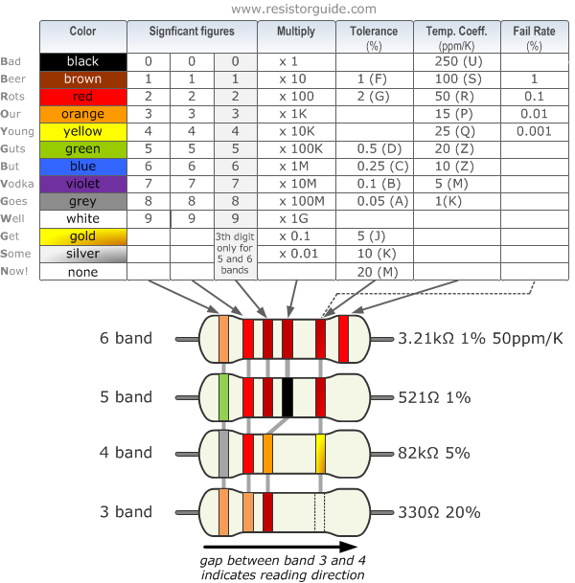

Figure 3.2: Resistor Colour Code

Normally, there are four strips printed on the resistor. The first and second strips show first and second digits. The third strips is multiplier and fourth strip are tolerance that can be accepted for the resistor. In this project, the value of resistor used are 1k ohm, 220 ohm and 10k ohm.

3.2.3 Relay

Relay are simple switches which are operated both electrical and mechanical. Relays consist of an electromagnet and also a set of contacts. The switching mechanism is carried out with the help of the electromagnet. Relay are used to control low-power signal circuit.

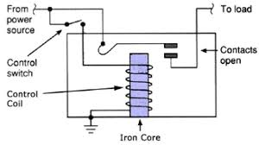

Figure 3.3: Relay Circuit diagram

3.2.4 Nodemcu (ESP8266)

NodeMCU is an open source LUA based firmware developed for ESP8266 Wi-Fi chip. NodeMCU boards consist of ESP8266 Wi-Fi enabled chop. The ESP 8266 is a low-cost Wi-Fi chip developed by Espressif Systems with TCP/IP protocol. NodeMCU used to send or receive data for other device.

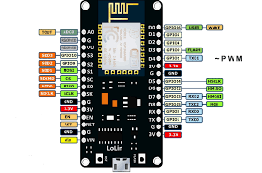

Figure 3.4: NodeMCU Pin

3.2.5 Coding of Smart Home System

Description of coding: Coding above explained to us about Smart Home System that process in NodeMCU with connected to Application Blynk.

3.3 Simulation Circuit

Proteus is a computer software that similar function to Multisim to simulate a circuit. The different between Proteus and Multisim is Proteus has two type of simulation which is ISI and ARES. ISIS is same as Multisim while ARES is simulation for arrangement of circuit on PCB using few step.

3.3.1 Schematic Circuit in ISIS

3.3.2 Producing PCB Circuit using ARES

3.3.3 Soldering Process

Soldering is a process that the component are soldered onto PCB. The tools that used are soldering iron, lead and lead sucker. In this process, the tip of soldering iron must clean first before use. Besides the soldering process must do careful because you might get hurt if there is an error. The soldering process is the next step after printed into PCB boards but due MCO movement Law PCB process cannot do but soldering process must be doing.

3.4 Design Process

A prototype design must be suitable with the project. To produce a neat and tidy prototype, proper tools and things for prototype are needed. All the connections are checked before the circuit moved onto the model. The process connecting are done careful because we don’t want an error during modelling prototype. The process moving circuit into model doesn’t happen because of some problem happen during project process. So the design process are tested on Breadboards. The process are showed in figure 3.20.

**CHAPTER 4**

**RESULTS & DISCUSSION**

This chapter will includes about the finished report in the theory scope and circuit operation used for this project. The circuit application is explained and the analysis results are also recorded during the implementation of circuit.

4.1 Circuit Operation

Every circuit has different operation to allow the project operates well and achieved the objective of the project. A zero-error circuit is important to make sure the circuit can function successfully.

Gambar circuit full

The circuit shown in figure 4.1 is used for smart home system that can control appliances automatically and save time and energy for user. NodeMCU acts as devices that give a command to the other devices. And relay acts as junction for controlling the appliance when NodeMCU send a command.

4.2 Results of Complete Circuit

The complete circuit is checked again because if there such an error. All pin is checked before connecting to real electrical power because this project all about home automation that control appliance at home, so it used electrical power when testing the circuit. Final checking is checked on breadboard since prototype doesn’t need to do. The Figure 4.2 is shown the complete circuit that has be done on breadboards.